Vehicle Make Classification and License Plate Recognition from Video Streams

Authors:
- Muhammad Abdullah
- Abdul Moiz
- Zia-ur-Rehman
- Abdullah Farooq
- Shaheer Murtaza Shehri
- Muhammad Sharjeel Farooq
Affiliation: BSAI-1-A, SEECS, NUST.
Date: 27th Aug, 2025

1. Introduction
Automatic vehicle-type detection and license plate recognition (LPR) are crucial tasks in intelligent transportation systems, traffic monitoring, law enforcement, and smart city applications. Traditionally, these two tasks have been studied and implemented separately, one focusing on classifying vehicles into makes or models, and the other on detecting and recognizing vehicle registration plates.
However, in real-world applications, combining both tasks into a single robust pipeline provides greater utility. For instance, the ability to simultaneously identify the make of a car and its license plate allows for improved vehicle re-identification, crime prevention, toll collection, and access control systems.
In this project, we design and implement an end-to-end pipeline capable of performing:
- Vehicle detection
- Vehicle make classification
- License plate detection
- License plate text recognition (OCR) with regex-based filtering
We further extend our approach to explore night-time video processing, where challenges such as low illumination, glare, and reflections make recognition significantly harder.

2. Existing Literature and Literature Gap
Several works have been carried out in vehicle detection, vehicle classification, and license plate recognition, but most of them treat these as isolated problems:
- Vehicle detection & classification: Models such as YOLO, Faster R-CNN, and ResNet-based classifiers have been widely used for car make/model classification. However, these are often restricted to limited datasets (e.g., U.S. or European cars) and fail when applied to region-specific vehicle distributions such as Pakistani roads.
- License plate recognition: State-of-the-art methods combine license plate detection (YOLO-based) with OCR techniques such as CRNNs, Tesseract, or custom models. Pretrained models exist, but many are trained on datasets with specific plate formats (U.S./EU), limiting their generalization to Pakistani plates.
- Combined approaches: Few existing pipelines attempt to jointly tackle both vehicle-type detection and license plate recognition.
Literature gap:
- Existing methods rarely combine make classification + license plate recognition into a single operational system.
- Current solutions struggle significantly with night-time videos due to glare, reflections, and low visibility.
- Many models are not tailored to Pakistani vehicles and plate formats, limiting real-world applicability in this region.
This project addresses these gaps by:
- Training a custom YOLO-based classifier on Pakistani vehicle datasets.
- Integrating license plate detection and OCR in the same pipeline.
- Applying preprocessing techniques to improve recognition in night-time videos.

3. Data Collection and Methodology

3.1 Vehicle Make Classification Dataset
- Initial dataset: 4k images from Roboflow (contained 48 classes). This dataset was noisy and inconsistent.
- Cleaning & expansion:
  - Dataset expanded to ~7k images by manually fetching images from PakWheels, OLX, Google Images, etc.
  - Images were annotated in Roboflow UI.
  - No new classes were added at this stage.
- Augmentations & preprocessing:
  - Applied multiple preprocessing steps and augmentations (resizing, flipping, cropping, rotations, shear controls, brightness adjustments, noise injection, etc.) in Roboflow.
  - Dataset expanded to ~13k images.
- Final dataset: Introduced an Unknown class with ~700 diverse global car images to reduce bias and force the classifier to reject uncertain predictions. After augmentations, the dataset reached ~15k images covering 49 classes.
Challenges faced:
- Severe bias toward Suzuki Carry class due to hidden dataset-level patterns (e.g., similar angles, backgrounds).
- Generalization problems when video quality or camera angles deviated from dataset distribution.
- Manual annotation was highly time-consuming and resource-intensive.

3.2 License Plate Recognition Dataset
Unlike vehicle classification, for LPR we leveraged pretrained models due to extensive availability of research and datasets. Our role was to integrate and adapt these models to Pakistani conditions:
- License plate detector: nickmuchi/yolos-small-finetuned-license-plate-detection (https:/huggingface.co/nickmuchi/yolos-small-finetuned-license-plate-detection).
- OCR: fast-plate-ocr (https://github.com/ankandrew/fast-plate-ocr).
- Regex filtering: Developed a custom regular expression covering common Pakistani license plate patterns to reject garbage OCR outputs.

4. Data Preprocessing
- Vehicle images: Cropped from detection bounding boxes and fed to classifier.
- Augmentation: Performed within Roboflow to improve generalization.
- License plate images: Cropped using plate detector; passed through OCR after preprocessing pipeline.
Night-time preprocessing pipeline (final best version):
- Apply gamma correction (γ=1.3) on entire car crop.
- Extract license plate region.
- Convert to grayscale.
- Apply gamma correction (γ=1.5).
- Apply CLAHE (clipLimit = 20).
- Feed result into OCR.
This sequence gave the best trade-off between enhancing visibility and avoiding excessive noise.

5. Proposed Methodology
The final pipeline works as follows:
- Vehicle Detection: YOLOv11x detector identifies bounding boxes for cars in video frames.
- Vehicle Classification: Each cropped car image is passed to a YOLOv11x classifier trained on 49 classes (including Unknown).
  - Post-processing check: Any prediction of “Suzuki Carry” is forced to “Unknown” to mitigate bias.
- License Plate Detection: Car crops are passed through pretrained YOLOS-small LPR detector to localize license plates.
- OCR & Regex Filtering: Plate crops are processed by fast-plate-ocr and then validated against regex. Garbage outputs are forced to default to “Unrecognizable”.
- Annotation & Output Video Generation: Each frame is reconstructed with:
  - Vehicle bounding box
  - Car make label (outside bounding box)
  - License plate text (inside bounding box)
Literature Gap Architecture:

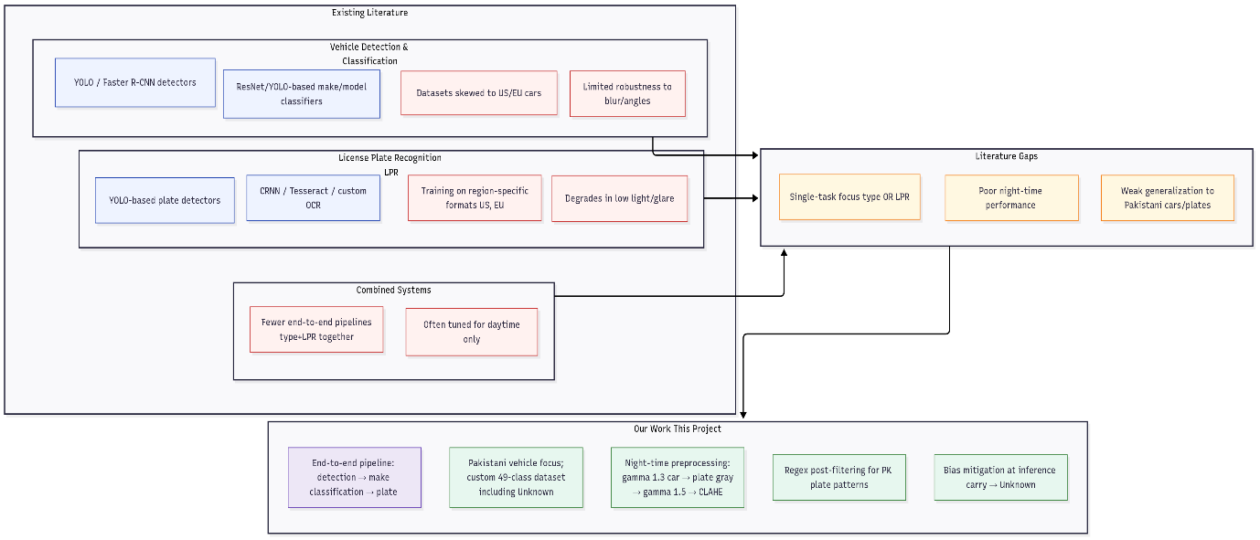

Technical Pipeline Architecture:

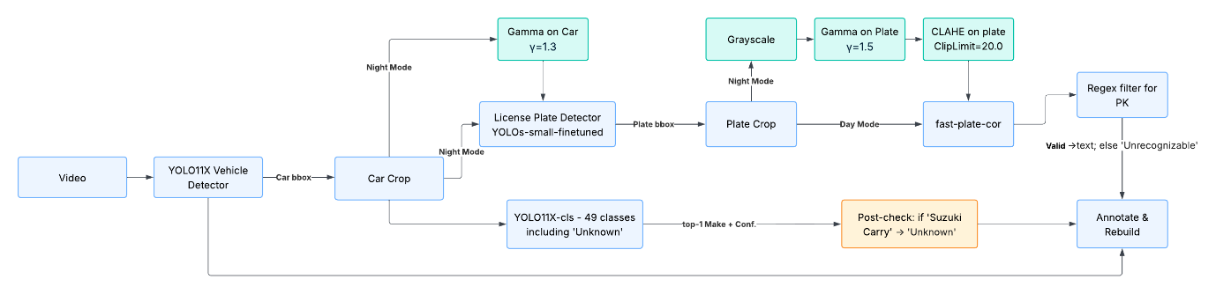

6. Results and Comparison
- The final model achieved highly accurate classifications for Pakistani vehicles given good video quality.
- License plate detection + OCR worked reliably for daytime videos.
- Night-time performance improved after preprocessing but still limited when glare/reflections completely obscured plates.
Comparison with existing approaches:
- Existing methods typically perform either vehicle classification OR license plate recognition.
- Our approach demonstrates a combined system for both tasks with region-specific personalization (Pakistani plates, cars).
- Result Videos:
- Without LPR:
- Without LPR Result Video 1
- Without LPR Result Video 2

- With LPR:
- With LPR Result Video 1
- With LPR Result Video 2
- With LPR Result Video 3
- With LPR Result Video 4
- With LPR Result Video 5

7. Conclusion and Future Work
This project successfully demonstrates a combined vehicle make classification and license plate recognition pipeline tailored to Pakistani conditions.
Key contributions:
- Built and cleaned a large custom dataset for vehicle classification.
- Integrated pretrained LPR models with region-specific regex filtering.
- Proposed an image preprocessing pipeline to improve recognition for night-time videos.
Limitations:
- Requires high-quality videos and sufficient vehicle size in frames.
- Vehicle classifier biased toward certain classes (e.g., Suzuki Carry) but the bias has been removed temporarily to show these classes as “Unknown”.
- Real-time inference demands state-of-the-art hardware due to heavy models and frame-by-frame processing.
Future directions:
- Vehicle Re-identification (ReID): Combine make classification, license plate recognition, and deep feature matching for tracking vehicles across multiple cameras.
- Dataset Expansion: Add more Pakistani car classes and improve diversity (angles, environments, lighting). Also remove fix problematic classes (e.g., Suzuki Carry) that are creating false biases.
- Efficiency: Reduce frame rate processing (e.g., 1 fps instead of 30 fps) to improve real-time applicability.
- Optimized storage: Revisit result saving strategies with better hardware or frame-rate adjustments.
- Advanced night-time enhancement: Explore deep-learning-based low-light enhancement methods beyond traditional preprocessing.

References
- Final Car Make Classification Dataset Version on Roboflow
- YOLO11 Documentation
- YOLOs-small-finetuned-license-plate-detection from Huggingface
- Ank Andrew's fast-plate-ocr on GitHub
- Without LPR Result Video 1
- Without LPR Result Video 2
- With LPR Result Video 1
- With LPR Result Video 2
- With LPR Result Video 3
- With LPR Result Video 4
- With LPR Result Video 5

